ARP Spoofing & Man-in-the-Middle (MITM) Traffic Interception in LAN
Abdul Basit Wani

Objective
To demonstrate how an attacker inside a local network can capture unencrypted HTTP traffic by performing ARP Spoofing.
This simulates a real-world MITM attack, showing why encryption and network security are important.

Lab Setup
Component | Details
Attacker | Kali Linux VM → 192.168.0.105
Victim | Windows Host OS → 192.168.0.101
Gateway | Router → 192.168.0.1
Interface | eth0
Tools Used | Arp spoof, Wireshark
All performed within my own network for ethical testing.

Execution
- Enabled Packet Forwarding in Kali:

echo 1 | sudo tee /proc/sys/net/ipv4/ip_forward

This allows Kali to relay traffic, so the victim continues browsing normally.

- Launched ARP Spoof (MITM Position Achieved):

sudo arpspoof -i eth0 -t 192.168.0.101 192.168.0.1
sudo arpspoof -i eth0 -t 192.168.0.1 192.168.0.101

Kali became the bridge between Windows and Router
All HTTP packets routed through Kali

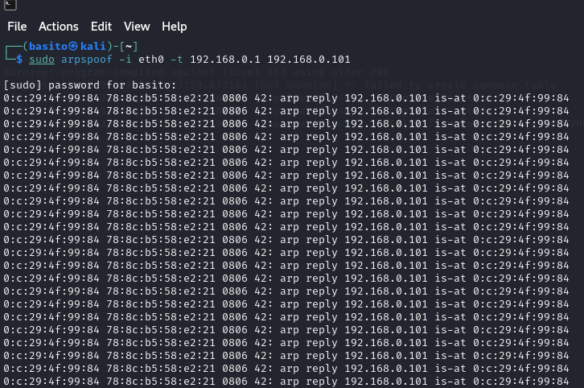

- Opened Wireshark, Filter Applied:



- Victim Accessed HTTP Website: Accessed testing website on victim machine

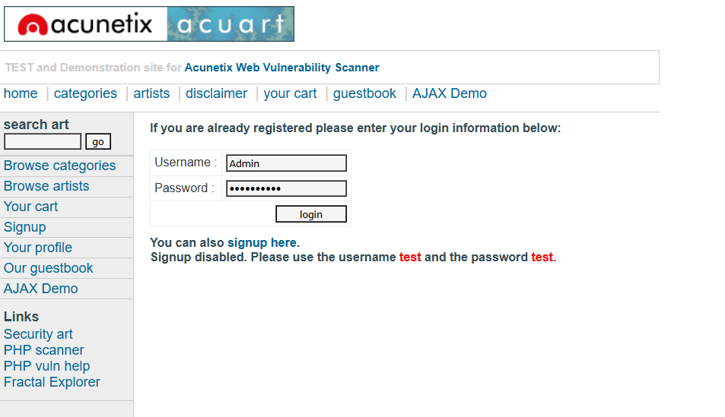

- Capturing Login Credentials:
Using Follow TCP Stream, I extracted raw request data: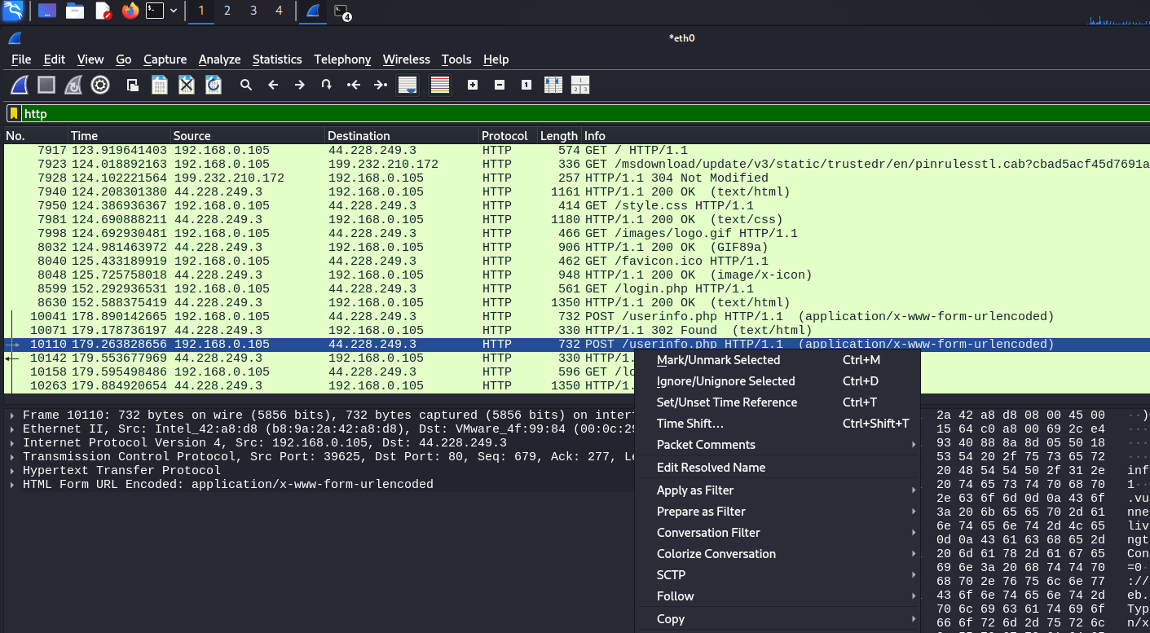
Upon further inspecting, Login credentials of the victim can be found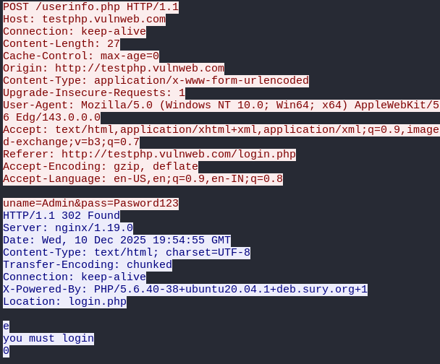

Results and Findings

The ARP spoofing simulation successfully placed the attacker in a Man-in-the-Middle position between the victim and the router. Once the victim’s traffic began flowing through the Kali machine, Wireshark captured all unencrypted HTTP activity in clear text. This included URLs visited, form submissions, and most critically, login credentials transmitted via HTTP POST requests. The results demonstrated how easily sensitive information can be exposed on a shared network when encryption is not enforced. The experiment confirmed that ARP spoofing remains a simple yet effective attack technique, and unprotected communication channels can be compromised without the victim noticing any interruption in network usage.

Mitigation techniques

To prevent ARP spoofing and similar MITM attacks, networks and applications must enforce stronger security controls. The most effective defence is ensuring all sensitive communication uses HTTPS, making intercepted packets unreadable. Additionally, network-level protections can detect or block forged ARP messages and reduce the attack surface.
Mitigation Points:
- Enforce HTTPS + HSTS for all login and data pages
- Enable Dynamic ARP Inspection (DAI) and DHCP Snooping
- Use Secure and HTTP Only cookie flags
- Segment internal networks to limit attacker movement
- Use VPN on public or untrusted networks
- Educate users to avoid entering credentials on HTTP sites.

